Praktikum V

(Pencerahan Citra Digital)

(C1-C2, D1-D6)

Nama : Ishom Nabil Umran Alihaq

Kelas : TI-CCIT 4B

NIM : 2207412040

C1

def aritmatikaAdd(self):  
 img1 = cv2.imread('BANG.jpeg', 0)  
 img2 = cv2.imread('BANG.jpeg', 0)  
 add_img = img1 + img2  
 cv2.imshow('Image 1 Original', img1)  
 cv2.imshow('Image 2 Original', img2)  
 cv2.imshow('Image add', add_img)  
 cv2.waitKey()  
  
def aritmatikaSubtract(self):  
 img1 = cv2.imread('BANG.jpeg', 0)  
 img2 = cv2.imread('BANG.jpeg', 0)  
 subtract = img1 - img2  
 cv2.imshow('Image 1 Original', img1)  
 cv2.imshow('Image 2 Original', img2)  
 cv2.imshow('Image Subtract', subtract)  
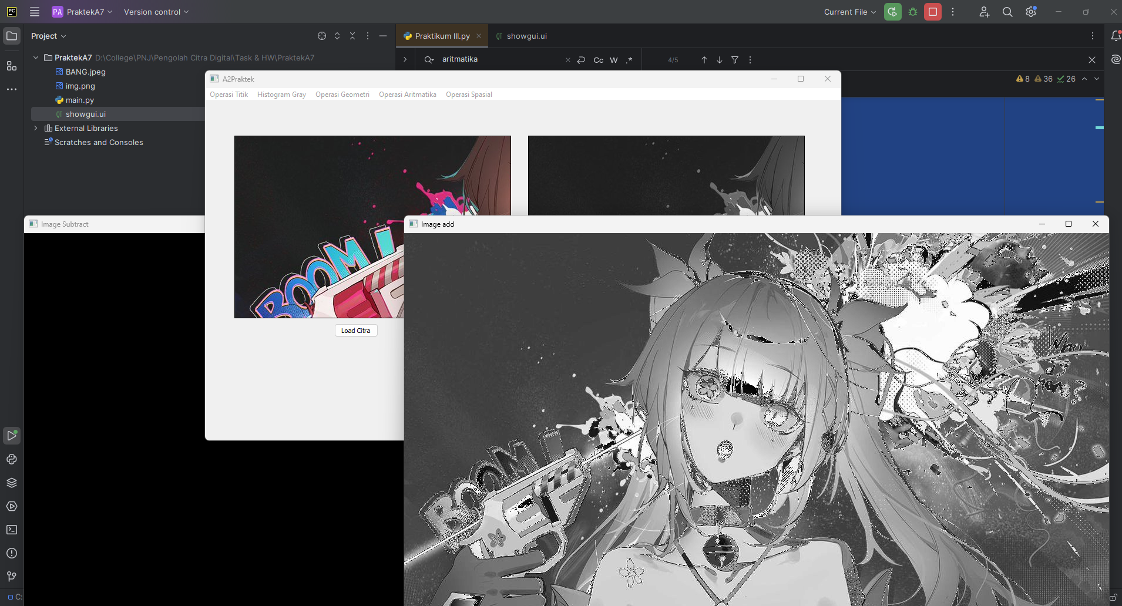 cv2.waitKey()

C2

def booleanAnd(self):  
 img1 = cv2.imread('BANG.jpeg', 1)  
 img2 = cv2.imread('BANG.jpeg', 1)  
 img1 = cv2.cvtColor(img1, cv2.COLOR_BGR2RGB)  
 img2 = cv2.cvtColor(img2, cv2.COLOR_BGR2RGB)  
 boolean_and = cv2.bitwise_and(img1, img2)  
 cv2.imshow('Image 1 Original', img1)  
 cv2.imshow('Image 2 Original', img2)  
 cv2.imshow('Image Boolean Add', boolean_and)  
 cv2.waitKey()  
  
def booleanOr(self):  
 img1 = cv2.imread('BANG.jpeg', 1)  
 img2 = cv2.imread('BANG.jpeg', 1)  
 img1 = cv2.cvtColor(img1, cv2.COLOR_BGR2RGB)  
 img2 = cv2.cvtColor(img2, cv2.COLOR_BGR2RGB)  
 boolean_or = cv2.bitwise_or(img1, img2)  
 cv2.imshow('Image 1 Original', img1)  
 cv2.imshow('Image 2 Original', img2)  
 cv2.imshow('Image Boolean Or', boolean_or)  
 cv2.waitKey()  
  
def booleanNot(self):  
 img1 = cv2.imread('BANG.jpeg', 1)  
 img2 = cv2.imread('BANG.jpeg', 1)  
 img1 = cv2.cvtColor(img1, cv2.COLOR_BGR2RGB)  
 img2 = cv2.cvtColor(img2, cv2.COLOR_BGR2RGB)  
 boolean_not = cv2.bitwise_not(img1, img2)  
 cv2.imshow('Image 1 Original', img1)  
 cv2.imshow('Image 2 Original', img2)  
 cv2.imshow('Image Boolean Not', boolean_not)  
 cv2.waitKey()  
  
def booleanXor(self):  
 img1 = cv2.imread('BANG.jpeg', 1)  
 img2 = cv2.imread('BANG.jpeg', 1)  
 img1 = cv2.cvtColor(img1, cv2.COLOR_BGR2RGB)  
 img2 = cv2.cvtColor(img2, cv2.COLOR_BGR2RGB)  
 boolean_xor = cv2.bitwise_xor(img1, img2)  
 cv2.imshow('Image 1 Original', img1)  
 cv2.imshow('Image 2 Original', img2)  
 cv2.imshow('Image Boolean Xor', boolean_xor)  
 cv2.waitKey()

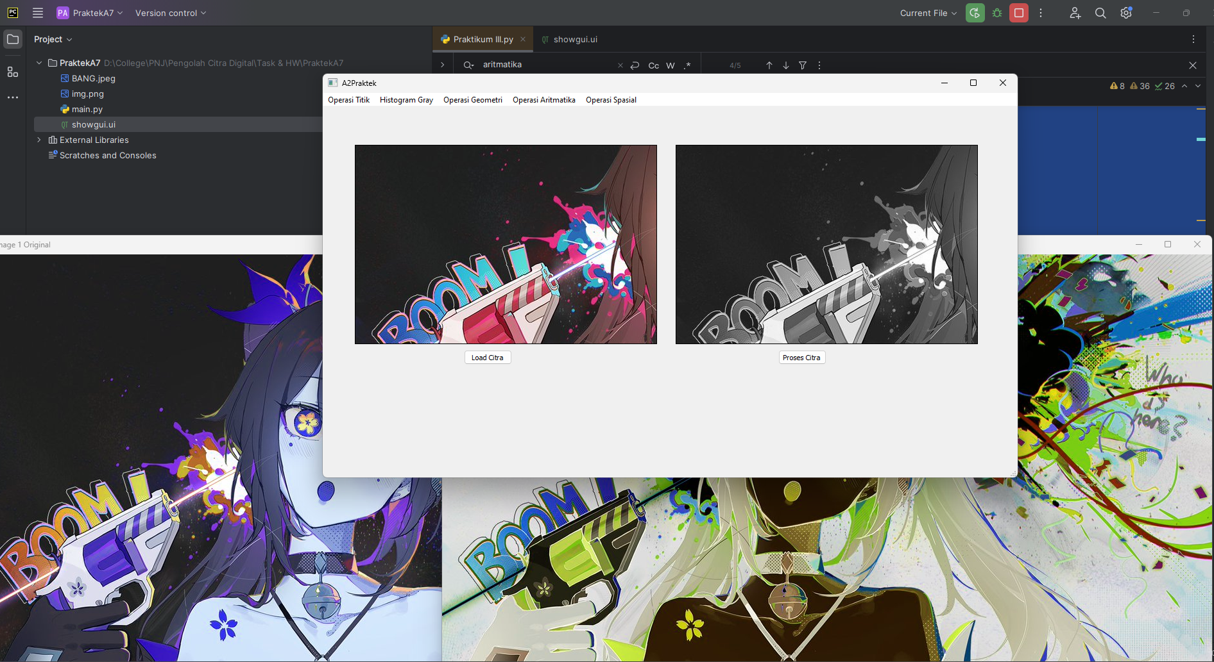

D1

# Konvolusi 2D  
self.actionKonvolusi_2D.triggered.connect(self.konvolusi2D)

def konvolusi2D(self):  
 kernel = np.array([  
 [1, 1, 1],  
 [1, 1, 1],  
 [1, 1, 1]  
 ])  
 img_input = cv2.imread('BANG.jpeg')  
 gray_image = cv2.cvtColor(img_input, cv2.COLOR_BGR2GRAY)  
 img_out = cv2.filter2D(gray_image, -1, kernel)  
 plt.imshow(img_out, cmap='gray', interpolation='bicubic')  
 plt.xticks([]), plt.yticks([])  
 cv2.imshow('Image belum konvolusi', img_input)  
 plt.show()

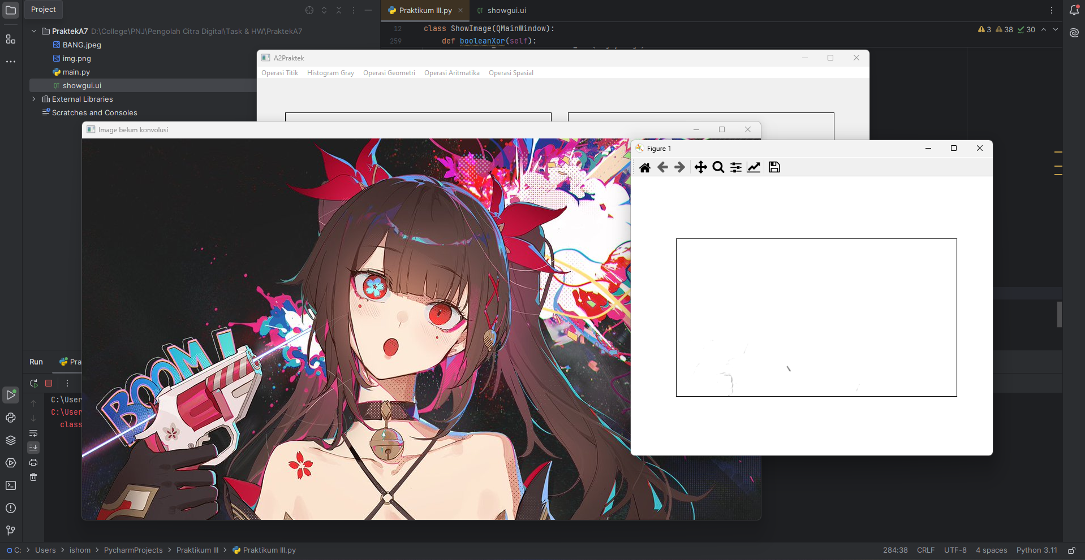

D2

# Mean Filter  
self.actionMean_Filter.triggered.connect(self.meanFilter)

def meanFilter(self):  
 mean = (1 / 9) * np.array([  
 [1, 1, 1],  
 [1, 1, 1],  
 [1, 1, 1]  
 ])  
 img_input = cv2.imread('BANG.jpeg')  
 gray_image = cv2.cvtColor(img_input, cv2.COLOR_BGR2GRAY)  
 img_out = cv2.filter2D(gray_image, -1, mean)  
 plt.imshow(img_out, cmap='gray', interpolation='bicubic')  
 plt.xticks([]), plt.yticks([])  
 cv2.imshow('Image belum konvolusi', img_input)  
 plt.show()

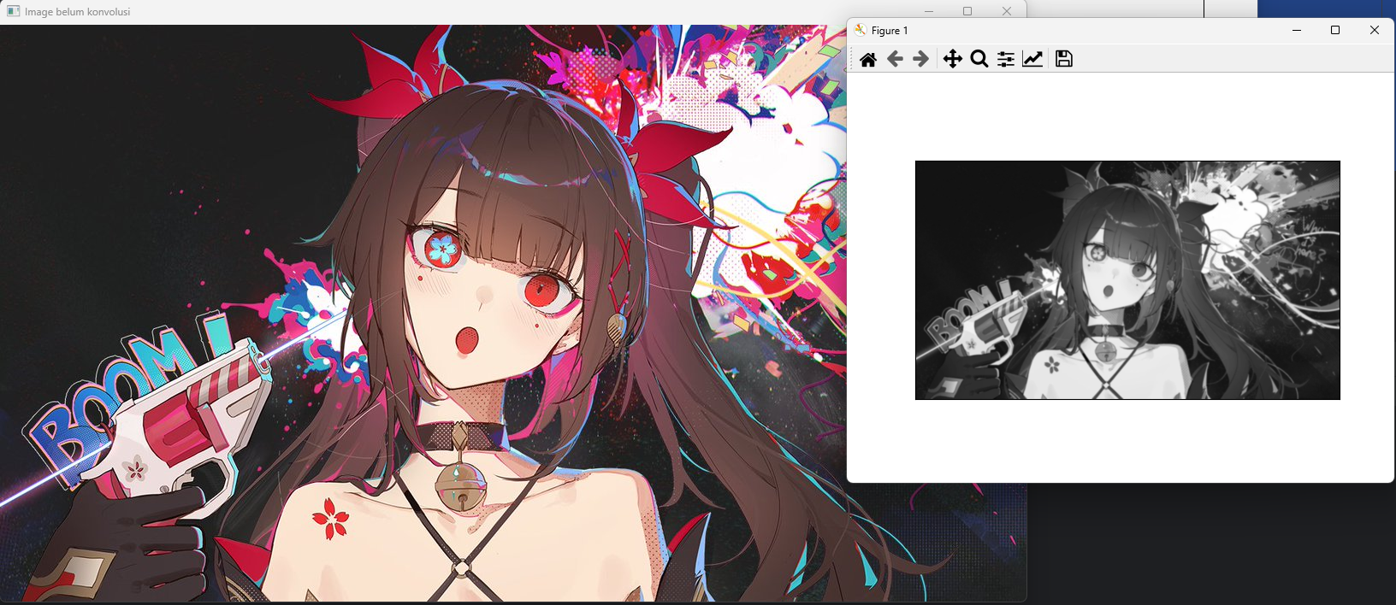

D3

# Smoothing using gaussFilter  
self.actionGauss_Filter.triggered.connect(self.gaussFilter)

def gaussFilter(self):  
 gauss = (1.0 / 345) * np.array([  
 [1, 5, 7, 5, 1],  
 [5, 20, 33, 20, 5],  
 [7, 33, 55, 33, 7],  
 [5, 20, 33, 20, 5],  
 [1, 5, 7, 5, 1]  
 ])  
 img_input = cv2.imread('BANG.jpeg')  
 gray_image = cv2.cvtColor(img_input, cv2.COLOR_BGR2GRAY)  
 img_out = cv2.filter2D(gray_image, -1, gauss)  
 plt.imshow(img_out, cmap='gray', interpolation='bicubic')  
 plt.xticks([]), plt.yticks([])  
 cv2.imshow('Image belum konvolusi', img_input)  
 plt.show()

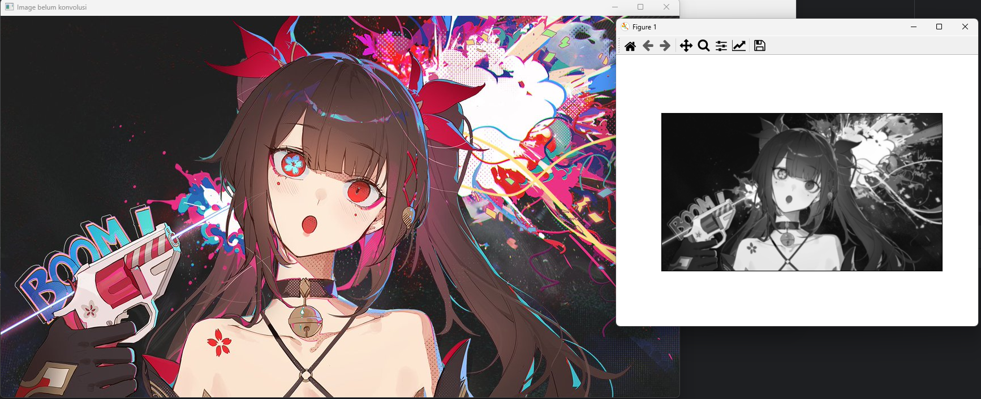

D4

# Sharpening  
self.actioni.triggered.connect(self.sharpeningI)  
self.actionii.triggered.connect(self.sharpeningII)  
self.actioniii.triggered.connect(self.sharpeningIII)  
self.actioniv.triggered.connect(self.sharpeningIV)  
self.actionv.triggered.connect(self.sharpeningV)  
self.actionvi.triggered.connect(self.sharpeningVI)

def sharpeningI(self):  
 sharpI = np.array([  
 [-1, -1, -1],  
 [-1, 8, -1],  
 [-1, -1, -1]  
 ])  
 img_input = cv2.imread('BANG.jpeg')  
 gray_image = cv2.cvtColor(img_input, cv2.COLOR_BGR2GRAY)  
 img_out = cv2.filter2D(gray_image, -1, sharpI)  
 plt.imshow(img_out, cmap='gray', interpolation='bicubic')  
 plt.xticks([]), plt.yticks([])  
 cv2.imshow('Image belum konvolusi', img_input)  
 plt.show()  
  
def sharpeningII(self):  
 sharpII = np.array([  
 [-1, -1, -1],  
 [-1, 9, -1],  
 [-1, -1, -1]  
 ])  
 img_input = cv2.imread('BANG.jpeg')  
 gray_image = cv2.cvtColor(img_input, cv2.COLOR_BGR2GRAY)  
 img_out = cv2.filter2D(gray_image, -1, sharpII)  
 plt.imshow(img_out, cmap='gray', interpolation='bicubic')  
 plt.xticks([]), plt.yticks([])  
 cv2.imshow('Image belum konvolusi', img_input)  
 plt.show()  
  
def sharpeningIII(self):  
 sharpIII = np.array([  
 [0, -1, 0],  
 [-1, 5, -1],  
 [0, -1, 0]  
 ])  
 img_input = cv2.imread('BANG.jpeg')  
 gray_image = cv2.cvtColor(img_input, cv2.COLOR_BGR2GRAY)  
 img_out = cv2.filter2D(gray_image, -1, sharpIII)  
 plt.imshow(img_out, cmap='gray', interpolation='bicubic')  
 plt.xticks([]), plt.yticks([])  
 cv2.imshow('Image belum konvolusi', img_input)  
 plt.show()  
  
def sharpeningIV(self):  
 sharpIV = np.array([  
 [1, 2, 1],  
 [-2, 5, -2],  
 [1, -2, 1]  
 ])  
 img_input = cv2.imread('BANG.jpeg')  
 gray_image = cv2.cvtColor(img_input, cv2.COLOR_BGR2GRAY)  
 img_out = cv2.filter2D(gray_image, -1, sharpIV)  
 plt.imshow(img_out, cmap='gray', interpolation='bicubic')  
 plt.xticks([]), plt.yticks([])  
 cv2.imshow('Image belum konvolusi', img_input)  
 plt.show()  
  
def sharpeningV(self):  
 sharpV = np.array([  
 [1, -2, 1],  
 [-2, 4, -2],  
 [1, -2, 1]  
 ])  
 img_input = cv2.imread('BANG.jpeg')  
 gray_image = cv2.cvtColor(img_input, cv2.COLOR_BGR2GRAY)  
 img_out = cv2.filter2D(gray_image, -1, sharpV)  
 plt.imshow(img_out, cmap='gray', interpolation='bicubic')  
 plt.xticks([]), plt.yticks([])  
 cv2.imshow('Image belum konvolusi', img_input)  
 plt.show()  
  
def sharpeningVI(self):  
 sharpVI = np.array([  
 [0, 1, 0],  
 [1, -4, 1],  
 [0, 1, 0]  
 ])  
 img_input = cv2.imread('BANG.jpeg')  
 gray_image = cv2.cvtColor(img_input, cv2.COLOR_BGR2GRAY)  
 img_out = cv2.filter2D(gray_image, -1, sharpVI)  
 plt.imshow(img_out, cmap='gray', interpolation='bicubic')  
 plt.xticks([]), plt.yticks([])  
 cv2.imshow('Image belum konvolusi', img_input)  
 plt.show()

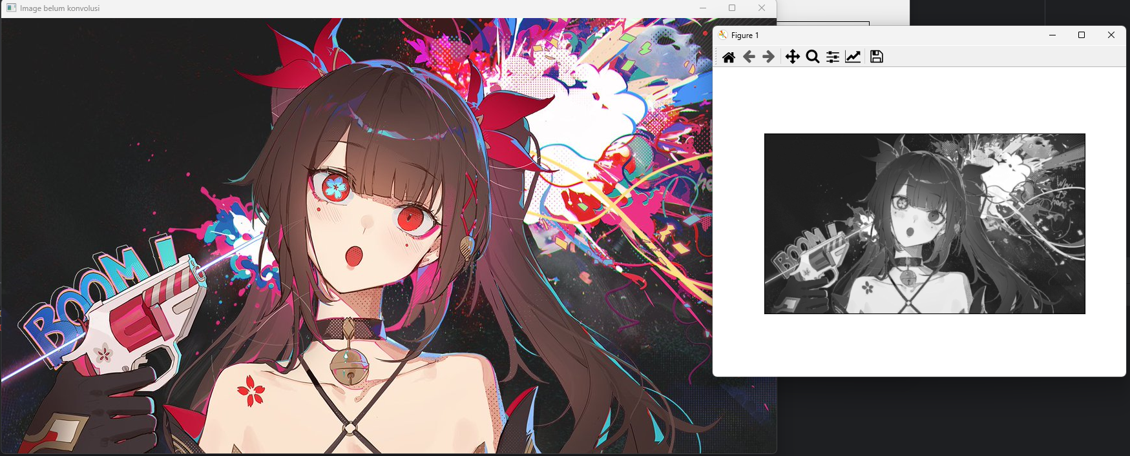

D5

# Median Filter  
self.actionMedian_Filter.triggered.connect(self.medianFilter)

def medianFilter(self):  
 img_input = cv2.imread('BANG.jpeg')  
 gray_image = cv2.cvtColor(img_input, cv2.COLOR_BGR2GRAY)  
 height, width = gray_image.shape  
 img_out = np.zeros((height, width), dtype=np.uint8)  
 for i in range(3, height - 3):  
 for j in range(3, width - 3):  
 neighbors = []  
 for k in range(-3, 4):  
 for l in range(-3, 4):  
 neighbors.append(gray_image[i + k][j + l])  
 neighbors.sort()  
 img_out[i, j] = neighbors[24]  
 plt.subplot(1, 2, 1), plt.imshow(cv2.cvtColor(img_input,  
 cv2.COLOR_BGR2RGB))  
 plt.title('Original Image'), plt.xticks([]), plt.yticks([])  
 plt.subplot(1, 2, 2), plt.imshow(img_out, cmap='gray')  
 plt.title('Median Filtered Image'), plt.xticks([]), plt.yticks([])  
 plt.show()

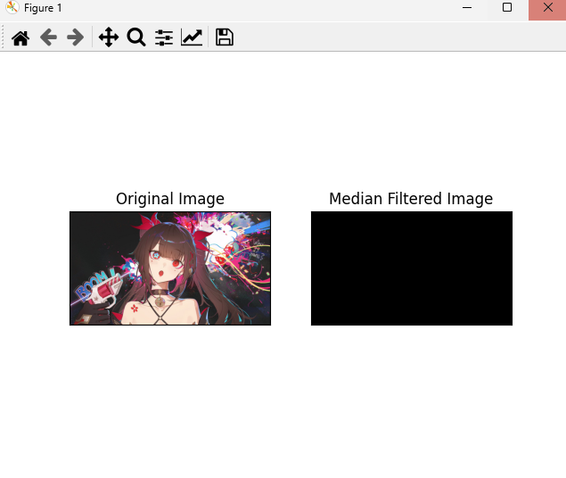

D6

# Min Max Filtering  
self.actionMax_Filter.triggered.connect(self.maxFilter)  
self.actionMin_Filter.triggered.connect(self.minFilter)

def maxFilter(self):  
 img_input = cv2.imread('BANG.jpeg')  
 gray_image = cv2.cvtColor(img_input, cv2.COLOR_BGR2GRAY)  
 height, width = gray_image.shape  
 img_out = np.zeros((height, width), dtype=np.uint8)  
 for i in range(3, height - 3):  
 for j in range(3, width - 3):  
 max_val = 0  
 for k in range(-3, 4):  
 for l in range(-3, 4):  
 pixel_val = gray_image[i + k][j + l]  
 if pixel_val > max_val:  
 max_val = pixel_val  
 img_out.itemset((i, j), max_val)  
 plt.subplot(1, 2, 1), plt.imshow(cv2.cvtColor(img_input,  
 cv2.COLOR_BGR2RGB))  
 plt.title('Original Image'), plt.xticks([]), plt.yticks([])  
 plt.subplot(1, 2, 2), plt.imshow(img_out, cmap='gray')  
 plt.title('Max Filtered Image'), plt.xticks([]), plt.yticks([])  
 plt.show()  
  
def minFilter(self):  
 img_input = cv2.imread('BANG.jpeg')  
 gray_image = cv2.cvtColor(img_input, cv2.COLOR_BGR2GRAY)  
 height, width = gray_image.shape  
 img_out = np.zeros((height, width), dtype=np.uint8)  
 for i in range(3, height - 3):  
 for j in range(3, width - 3):  
 min_val = 255  
 for k in range(-3, 4):  
 for l in range(-3, 4):  
 pixel_val = gray_image[i + k][j + l]  
 if pixel_val < min_val:  
 min_val = pixel_val  
 img_out.itemset((i, j), min_val)  
 plt.subplot(1, 2, 1), plt.imshow(cv2.cvtColor(img_input,  
 cv2.COLOR_BGR2RGB))  
 plt.title('Original Image'), plt.xticks([]), plt.yticks([])  
 plt.subplot(1, 2, 2), plt.imshow(img_out, cmap='gray')  
 plt.title('Min Filtered Image'), plt.xticks([]), plt.yticks([])  
 plt.show()

